Automate a Web Application(Selenium)

# àLogin.java

package com;

import org.openqa.selenium.By;

import org.openqa.selenium.WebDriver; import org.openqa.selenium.WebElement;

import org.openqa.selenium.chrome.ChromeDriver; import io.github.bonigarcia.wdm.WebDriverManager; public class Login {

public static void main(String[] args) throws InterruptedException { WebDriverManager.chromedriver().setup();

WebDriver driver = new ChromeDriver();

// Navigate to the login page String path = "login.html";

String url = Login.class.getClassLoader().getResource(path).toString(); driver.get(url);

// Login Automation

login(driver, "ashok125[@gmail.com"](mailto:himasree1611@gmail.com), "Ashok@123");

// Pause for 5 seconds (5000 milliseconds) before closing the browser Thread.sleep(1000);

// Close the browser driver.quit();

}

private static void login(WebDriver driver, String email, String password) throws InterruptedException {

WebElement emailInput = driver.findElement(By.id("login-email")); WebElement passwordInput = driver.findElement(By.id("login-password"));

WebElement submitButton = driver.findElement(By.xpath("//button[text()='Submit']"));

// Fill out the login form emailInput.sendKeys(email); passwordInput.sendKeys(password); Thread.sleep(2000);

// Click the submit button

submitButton.click(); Thread.sleep(1000); System.out.println("Login Success");

}

}

# àRegistration.java

package com;

import org.openqa.selenium.By;

import org.openqa.selenium.WebDriver; import org.openqa.selenium.WebElement;

import org.openqa.selenium.chrome.ChromeDriver; import io.github.bonigarcia.wdm.WebDriverManager; public class Registration {

public static void main(String[] args) throws InterruptedException { WebDriverManager.chromedriver().setup();

WebDriver driver = new ChromeDriver();

// Display the welcome page displayWelcomePage(driver);

// Pause for 2 seconds (2000 milliseconds) to manually complete the registration (for demonstration purposes)

Thread.sleep(2000);

// Print the "Register Success" message System.out.println("Register Success");

// Pause for 2 seconds (2000 milliseconds) before displaying the registration page Thread.sleep(2000);

// Registration Automation

registerNewEmployee(driver, "ashok", "ashok125[@gmail.com"](mailto:himasree1611@gmail.com), "Ashok@123");

// Close the browser driver.quit();

}

private static void displayWelcomePage(WebDriver driver) {

String welcomePath = Registration.class.getResource("/welcome.html").toString(); driver.get(welcomePath);

}

private static void registerNewEmployee(WebDriver driver, String name, String email, String password) throws InterruptedException {

String registrationPath = Registration.class.getResource("/registration.html").toString(); driver.get(registrationPath);

// Fill out the registration form

WebElement nameInput = driver.findElement(By.id("name")); WebElement emailInput = driver.findElement(By.id("email")); WebElement passwordInput = driver.findElement(By.id("password"));

WebElement registerButton = driver.findElement(By.id("register-button"));

nameInput.sendKeys(name); emailInput.sendKeys(email); passwordInput.sendKeys(password); Thread.sleep(2000);

// Click the registration button registerButton.click();

// Check if the window is still open

if (!driver.getWindowHandles().isEmpty()) {

// Wait for the success message try {

WebElement successMessage = driver.findElement(By.xpath("//h1[contains(text(), 'Register Success')]"));

if (successMessage.isDisplayed()) { System.out.println("Register Success");

}

} catch (org.openqa.selenium.NoSuchElementException e) { System.out.println("Registerion page closed");

}

} else {

System.out.println("Register Failed: Window closed");

}

}

}

# àLoginTest.java

package com;

import org.openqa.selenium.By;

import org.openqa.selenium.WebDriver; import org.openqa.selenium.WebElement;

import org.openqa.selenium.chrome.ChromeDriver; import org.testng.annotations.AfterClass;

import org.testng.annotations.BeforeClass; import org.testng.annotations.Test;

import io.github.bonigarcia.wdm.WebDriverManager; public class LoginTest {

private WebDriver driver; @BeforeClass

public void setUp() { WebDriverManager.chromedriver().setup(); driver = new ChromeDriver();

String path = LoginTest.class.getClassLoader().getResource("login.html").getPath(); driver.get("file://" + path);

}

@Test

public void testLogin() throws InterruptedException { loginEmployee(driver, "[ashoksree1611@gmail.com",](mailto:ashoksree1611@gmail.com%22,%20) "Ashok@123");

// Optionally, add assertions to verify login success or check for error messages

}

@AfterClass

public void tearDown() { driver.quit();

}

private void loginEmployee(WebDriver driver, String email, String password) throws InterruptedException {

WebElement emailInput = driver.findElement(By.name("email")); WebElement passwordInput = driver.findElement(By.name("password"));

WebElement submitButton = driver.findElement(By.xpath("//button[text()='Submit']"));

// Fill out the login form emailInput.sendKeys(email); passwordInput.sendKeys(password);

Thread.sleep(2000);

// Click the "Submit" button submitButton.click();

// Optionally, add code to handle login success or failure scenarios

}

}

# àRegistrationTest.java

package com;

import org.openqa.selenium.By;

import org.openqa.selenium.WebDriver; import org.openqa.selenium.WebElement;

import org.openqa.selenium.chrome.ChromeDriver;

import org.testng.annotations.AfterClass; import org.testng.annotations.BeforeClass; import org.testng.annotations.Test;

import io.github.bonigarcia.wdm.WebDriverManager; public class RegistrationTest {

private WebDriver driver; @BeforeClass

public void setup() { WebDriverManager.chromedriver().setup(); driver = new ChromeDriver();

driver.manage().timeouts().implicitlyWait(10, java.util.concurrent.TimeUnit.SECONDS);

}

@Test(priority = 1)

public void testWelcomePage() {

// Test displaying the welcome page displayWelcomePage();

// Pause for 5 seconds (5000 milliseconds) to manually interact with the page (for demonstration purposes)

sleep(5000);

// Print the "Welcome Page Test Successful" message System.out.println("Welcome Page Test Successful");

}

@Test(priority = 2)

public void testRegistrationProcess() throws InterruptedException {

// Test the registration process displayRegistrationPage();

// Fill out the registration form

registerNewEmployee("ashok", "ashok125[@gmail.com",](mailto:himasree161@gmail.com) "Ashok@123");

// Pause for 5 seconds (5000 milliseconds) before checking for the "Register Success" message

sleep(5000);

// Check for the "Register Success" message boolean successMessageDisplayed =

isElementDisplayed(By.xpath("//h1[contains(text(), 'Register Success')]")); if (successMessageDisplayed) {

System.out.println("Register Success");

}

}

@AfterClass

public void teardown() {

// Close the browser after the test is executed if (driver != null) {

driver.quit();

}

}

private void displayWelcomePage() {

String welcomePath = RegistrationTest.class.getResource("/welcome.html").toString(); driver.get(welcomePath);

}

private void displayRegistrationPage() {

String registrationPath = RegistrationTest.class.getResource("/registration.html").toString();

driver.get(registrationPath);

}

private void registerNewEmployee(String name, String email, String password) throws InterruptedException {

WebElement nameInput = driver.findElement(By.id("name")); WebElement emailInput = driver.findElement(By.id("email")); WebElement passwordInput = driver.findElement(By.id("password"));

WebElement registerButton = driver.findElement(By.id("register-button")); nameInput.sendKeys(name);

emailInput.sendKeys(email); passwordInput.sendKeys(password); Thread.sleep(2000);

// Click the registration button registerButton.click();

}

private boolean isElementDisplayed(By locator) { try {

return driver.findElement(locator).isDisplayed();

} catch (org.openqa.selenium.NoSuchElementException e) { return false;

}

}

private void sleep(long milliseconds) { try {

Thread.sleep(milliseconds);

} catch (InterruptedException e) { e.printStackTrace();

}

}

}

# àLogin.html

|  |
| --- |
|  |
|  |  |

à**Registration.html**

|  |
| --- |
|  |
|  |  |

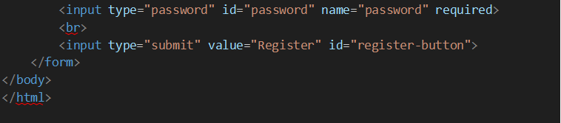

# àWelcome.html

|  |
| --- |
|  |
|  |  |

à**Pom.xml**

|  |
| --- |
|  |
|  |  |

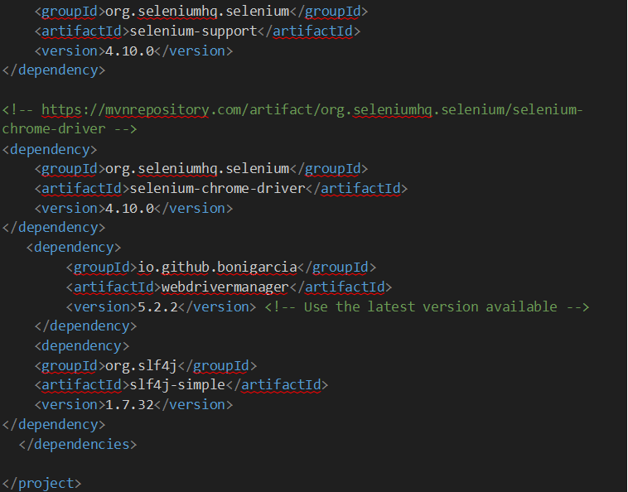

# àDefault test.html

|  |
| --- |
|  |
|  |  |

return 0;

}

else {

e.style.display = 'block'; return 1;

}

}

function toggleBox(szDivId, elem, msg1, msg2)

{

var res = -1; if (document.getElementById) { res = flip(document.getElementById(szDivId));

}

else if (document.all) {

// this is the way old msie versions work res = flip(document.all[szDivId]);

}

if(elem) {

if(res == 0) elem.innerHTML = msg1; else elem.innerHTML = msg2;

}

}

function toggleAllBoxes() {

if (document.getElementsByTagName) {

d = document.getElementsByTagName('div'); for (i = 0; i < d.length; i++) {

if (d[i].className == 'log') { flip(d[i]);

}

}

}

}

// -->

</script>

</head>

<body>

<h2 align='center'>Default test</h2><table border='1' align="center">

<tr>

<td>Tests passed/Failed/Skipped:</td><td>1/0/0</td>

</tr><tr>

<td>Started on:</td><td>Thu Jul 20 11:21:54 IST 2023</td>

</tr>

<tr><td>Total time:</td><td>4 seconds (4374 ms)</td>

</tr><tr>

<td>Included groups:</td><td></td>

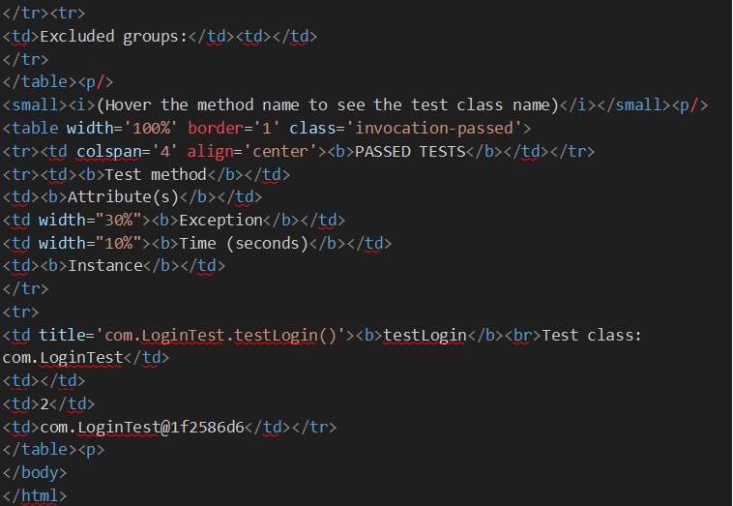

# àTestng-failed.xml

|  |
| --- |
|  |
|  |  |

à**Default test.xml**

|  |
| --- |
|  |
|  |  |

# àClasses.html

|  |
| --- |
|  |
|  |  |